THE FOLLOWING PHOTOGRAPHS WERE TAKEN DURING THE SITE VISIT, DATE: 13 TO 15 JULY 2016
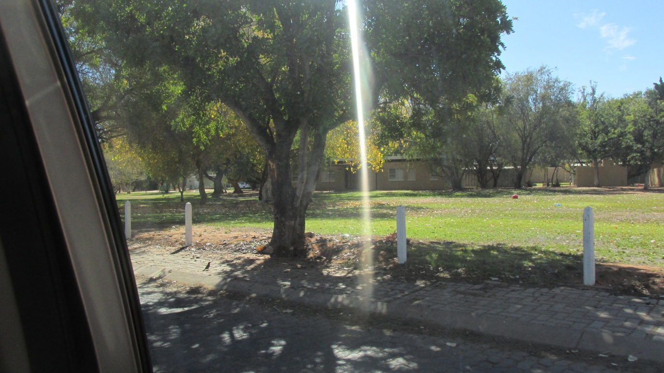
Figure 1: Residential area in Aggeneis Town

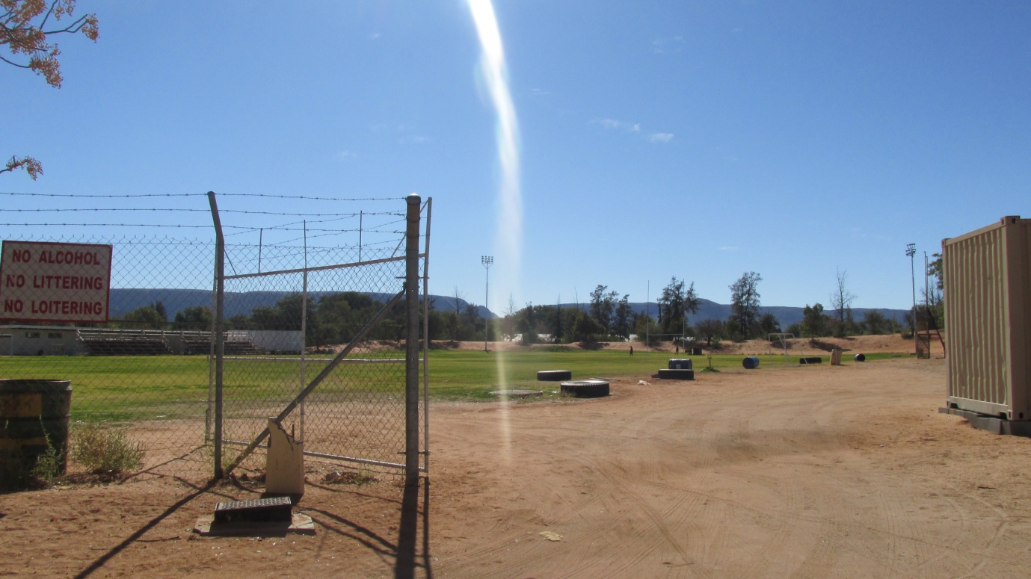
Figure 2: School field in Aggeneys town
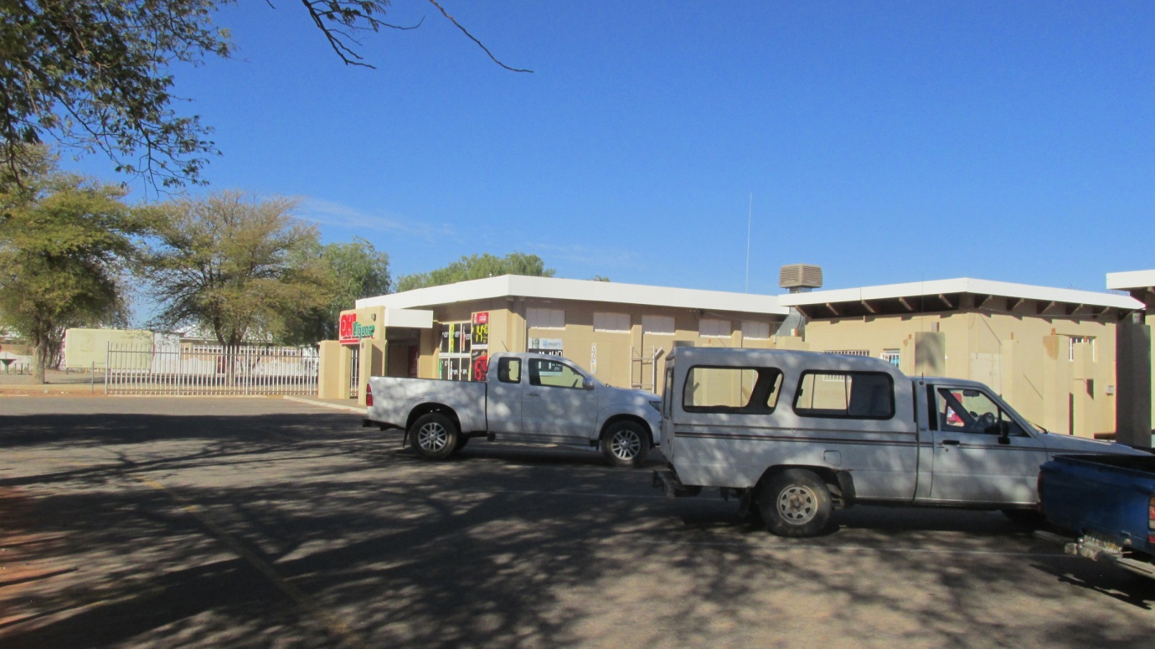
Figure 3: Shopping area in Aggeneys town

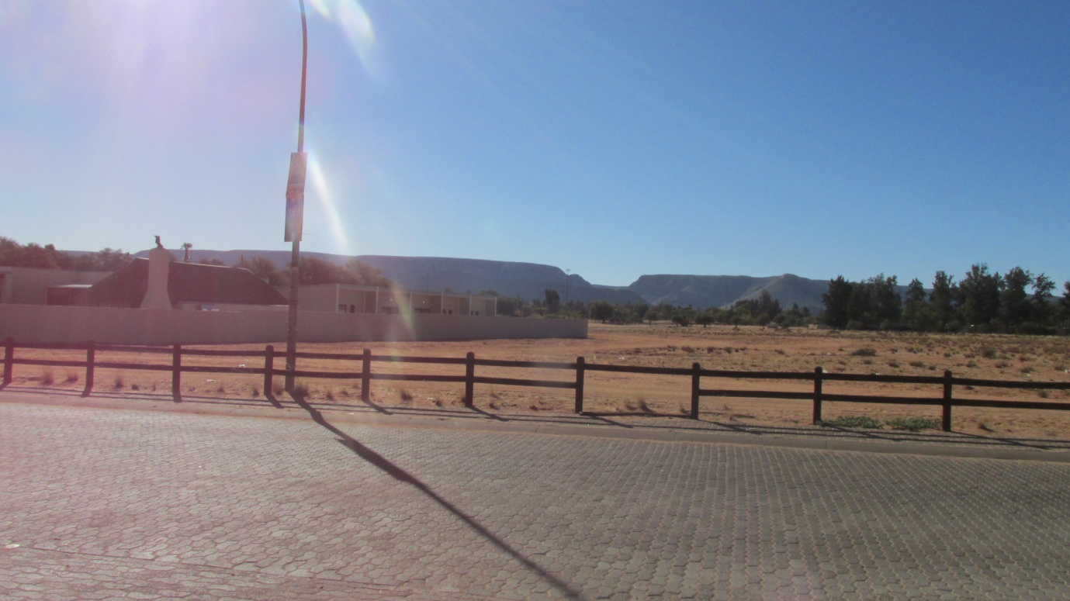
Figure 4: Aggeneys town showing mountains in the background, possibly part of Black Mountain Mine resources
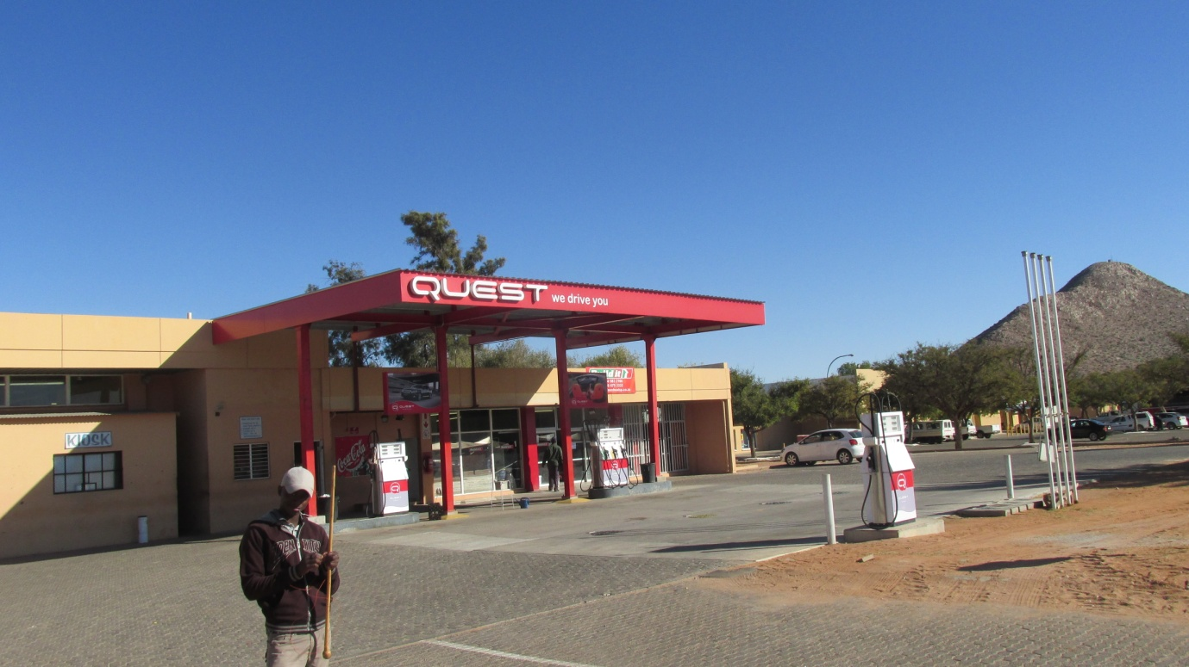
Figure 5: Filling Station at Aggeneys town

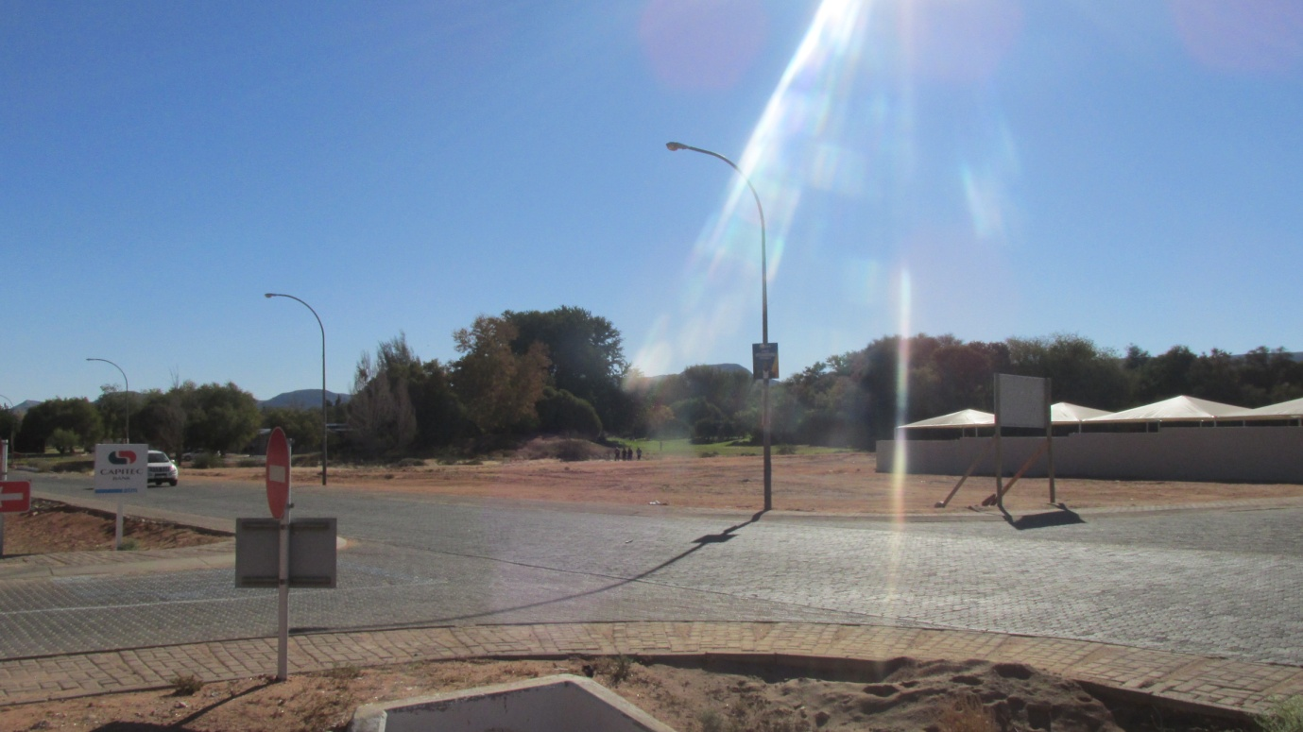
Figure 6: Route exit out of Aggeneys town
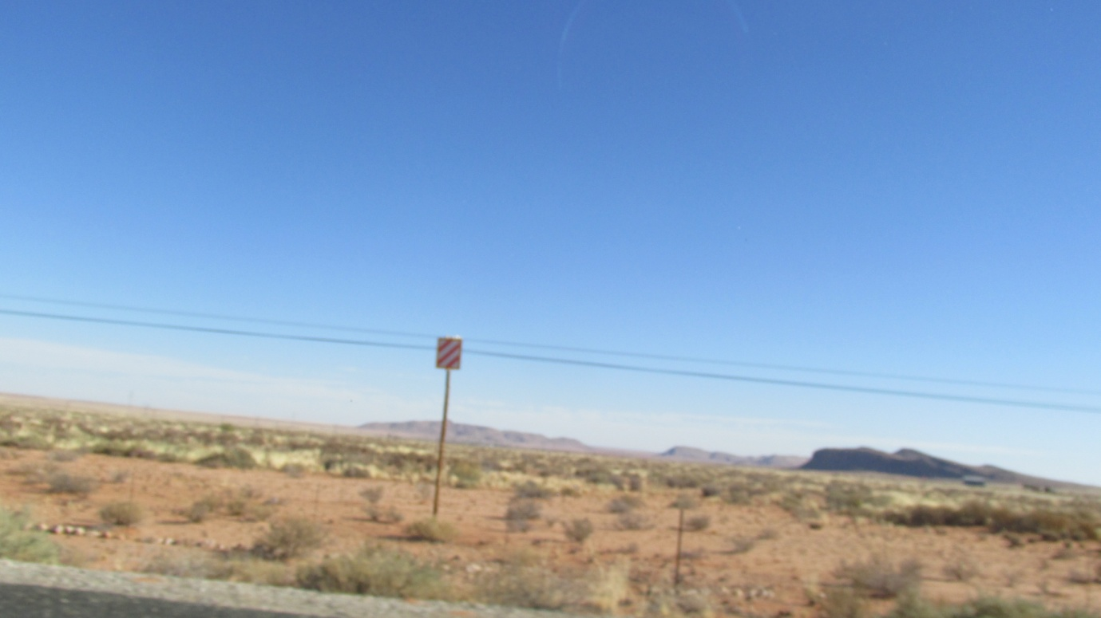
Figure 7: Surrounding environment in the outskirts of Aggeneys town

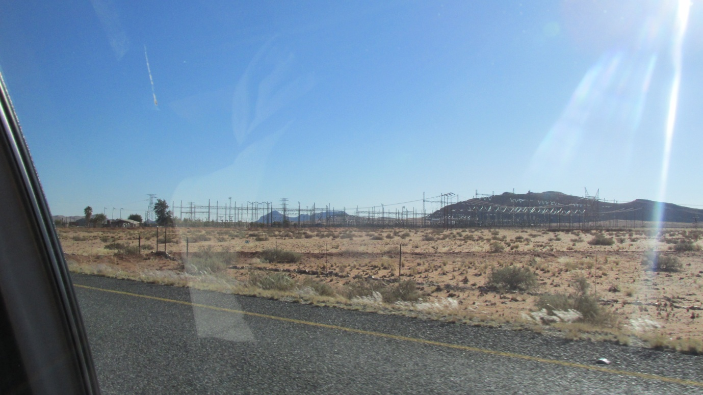
Figure 8: Aggeneis substation approximately 5km south west of Aggeneys town
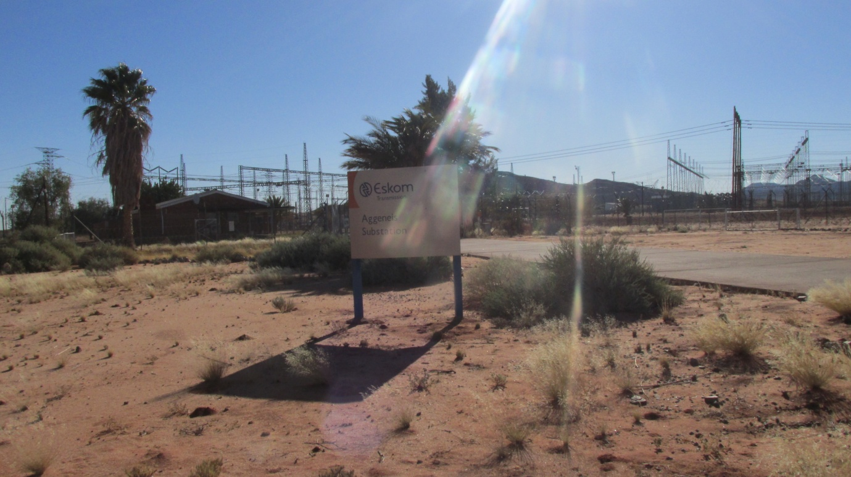
Figure 9: Entrance area at Aggeneis substation

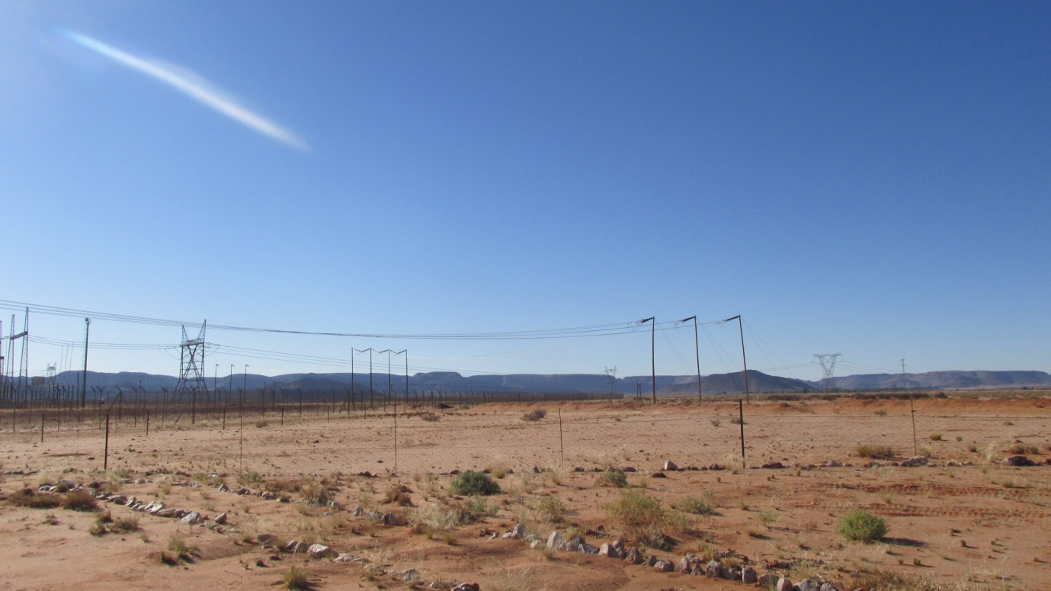
Figure 10: Powerline connecting to Aggeneis substation

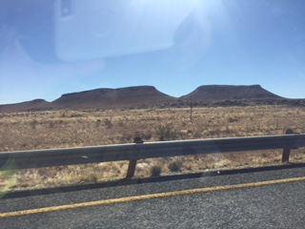
Figure 11: Mountains a few kilometres after leaving Aggeneis substation on the right hand side of N14, heading towards Pofadder direction

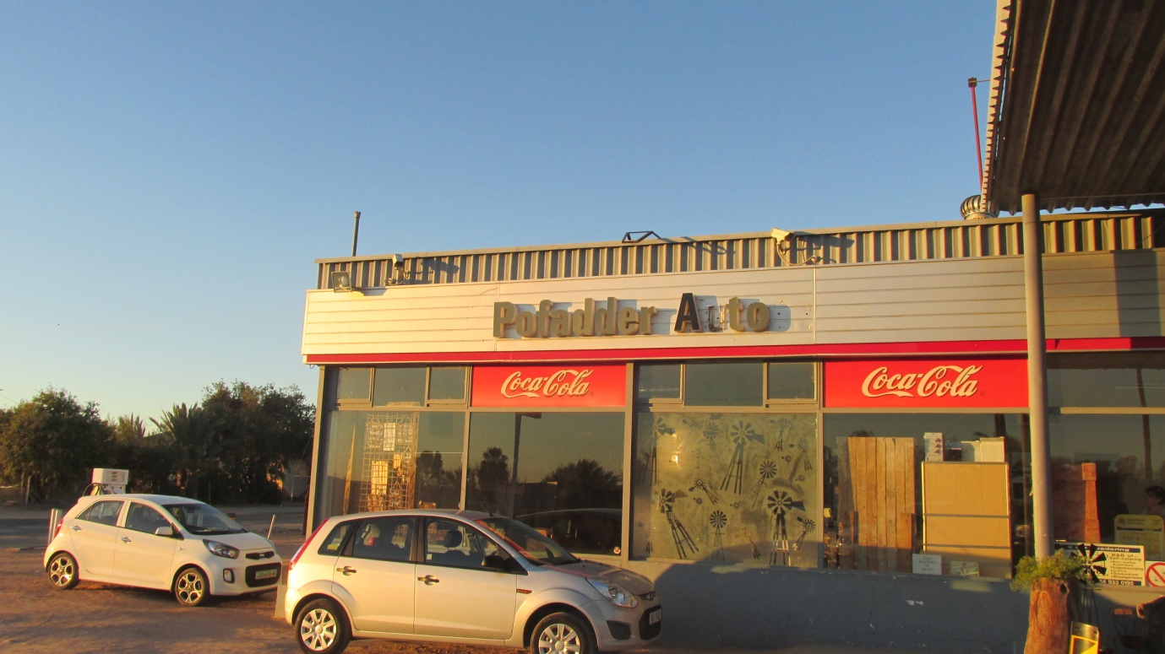
Figure 12: Pofadder filling station on the right hand side of N14 heading towards Upington direction

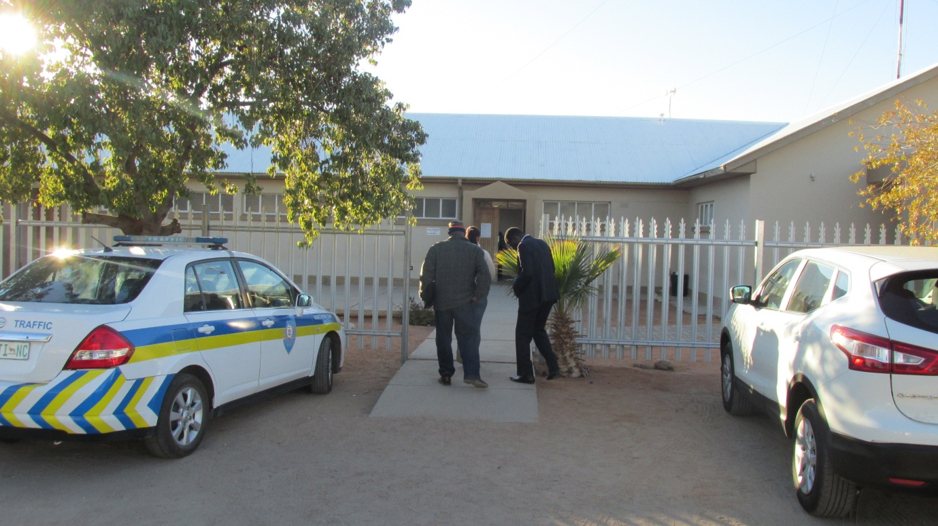
Figure 13: Khai Ma Municipality in Pofadder town

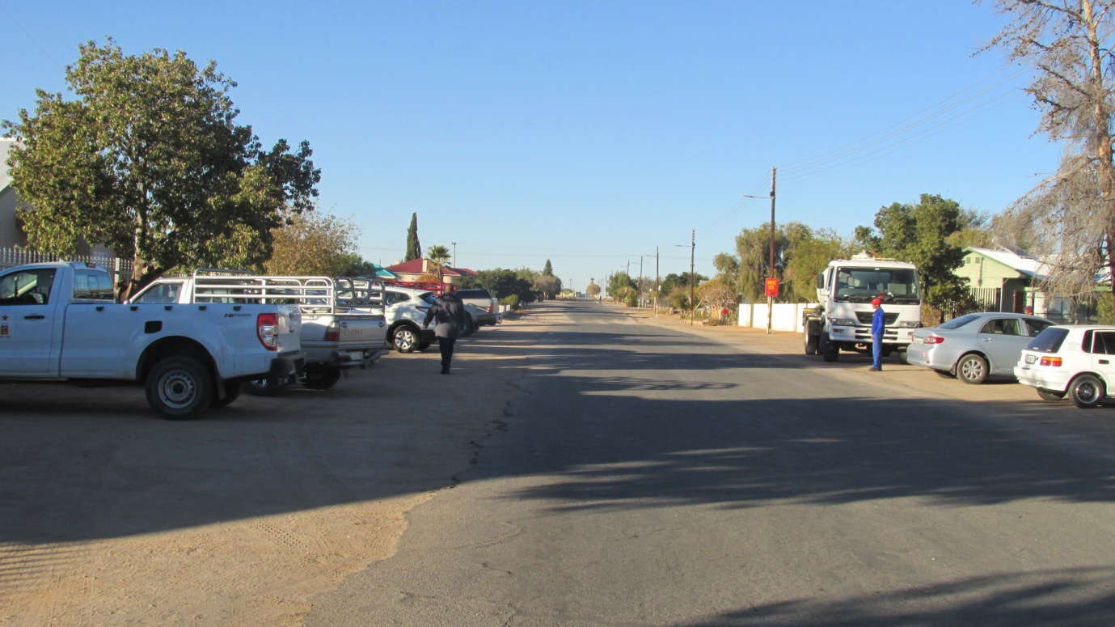
Figure 14: Inside of Pofadder town
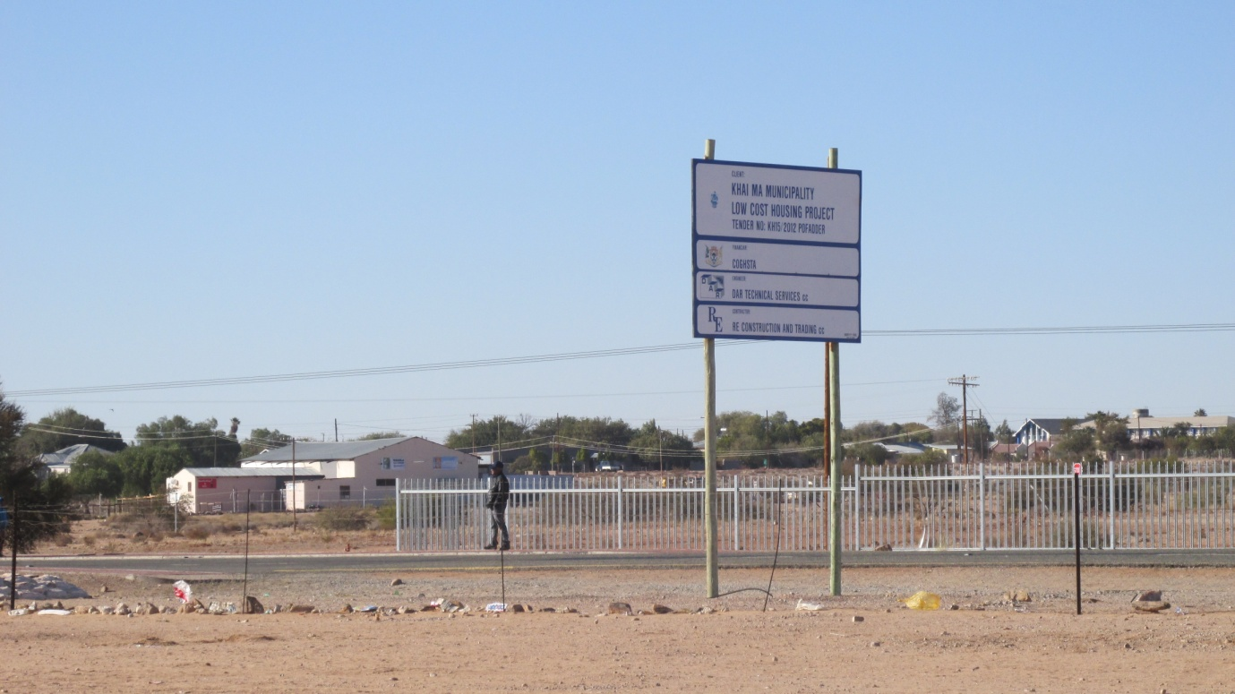
Figure 15: Pofadder town with N14 traversing the town

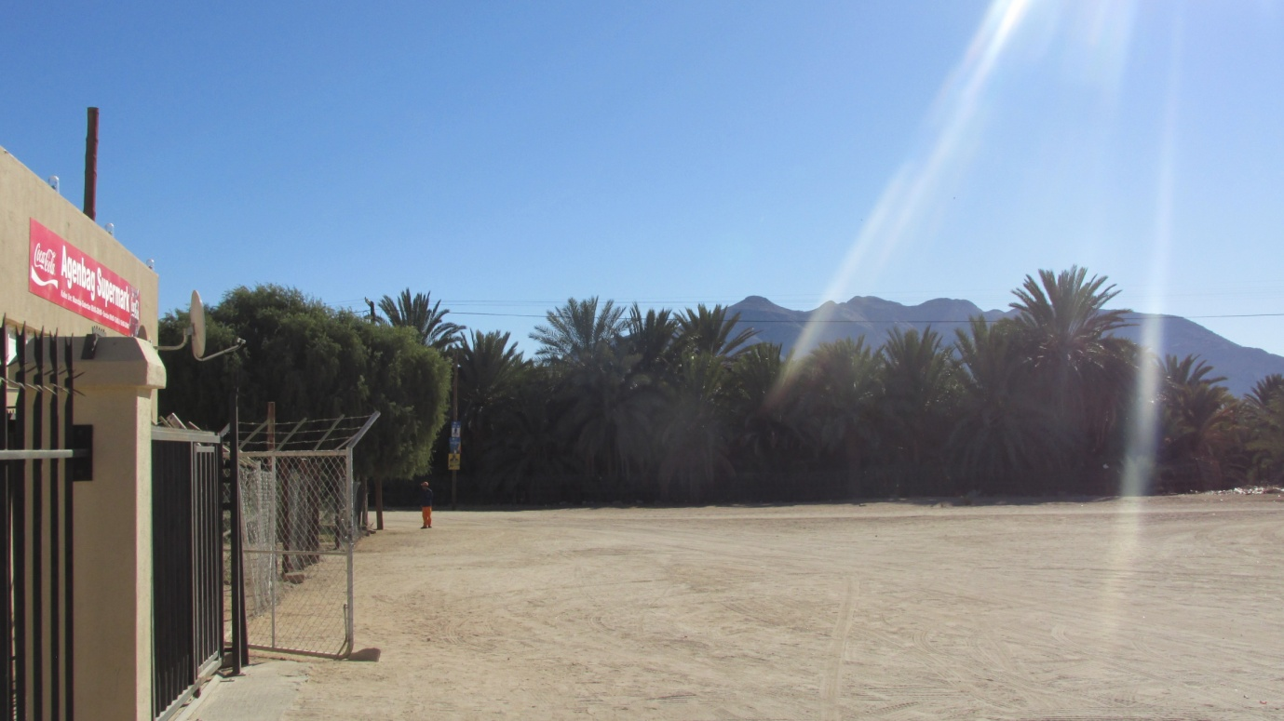
Figure 16: Pella town
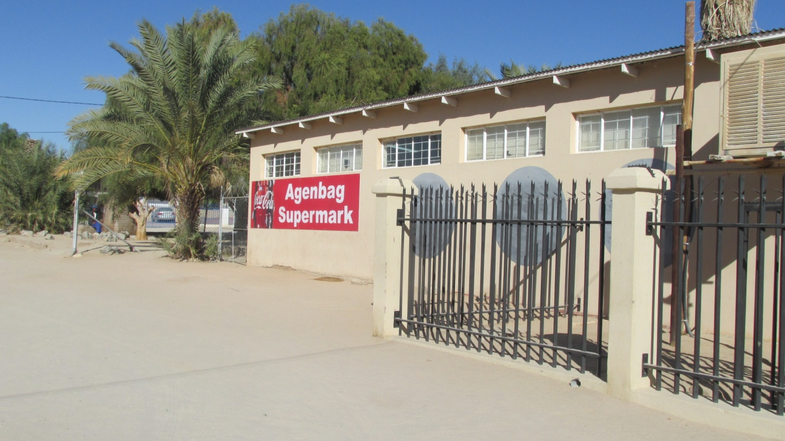
Figure 17: Shop at Pella town

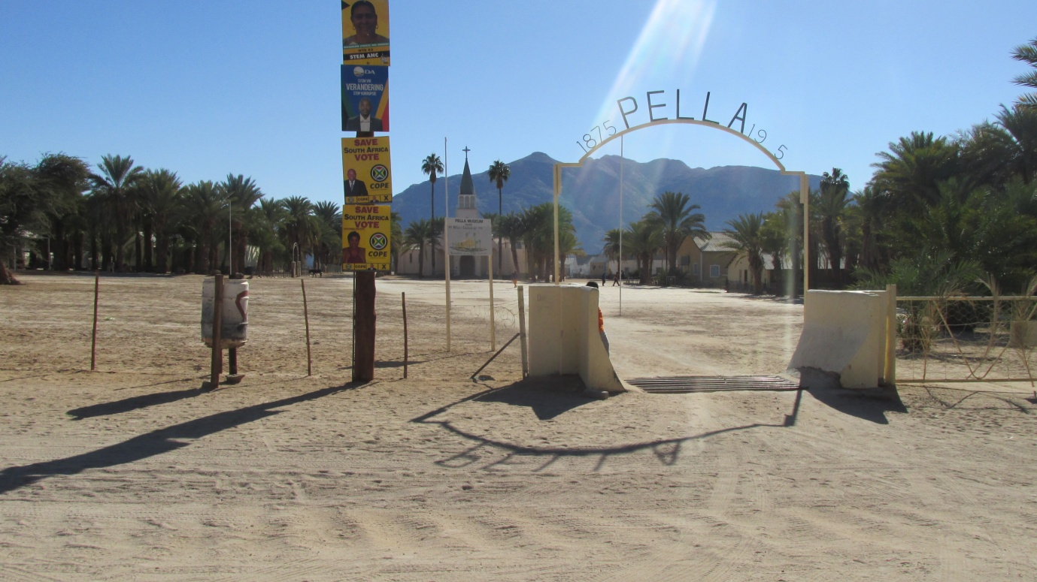
Figure 18: Pella Catholic Church and Museum
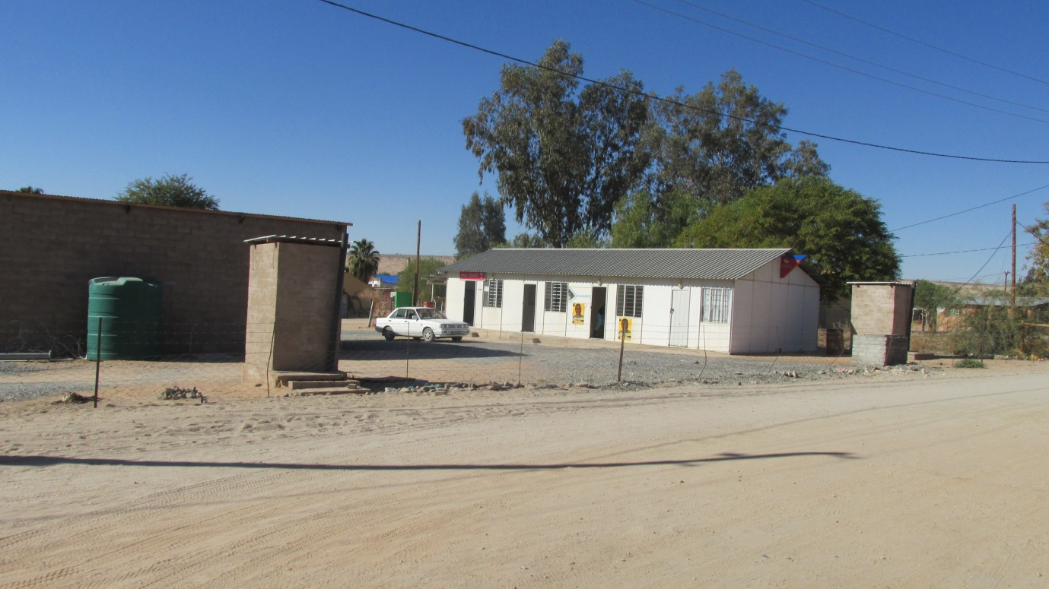
Figure 19: Pella Administrative area

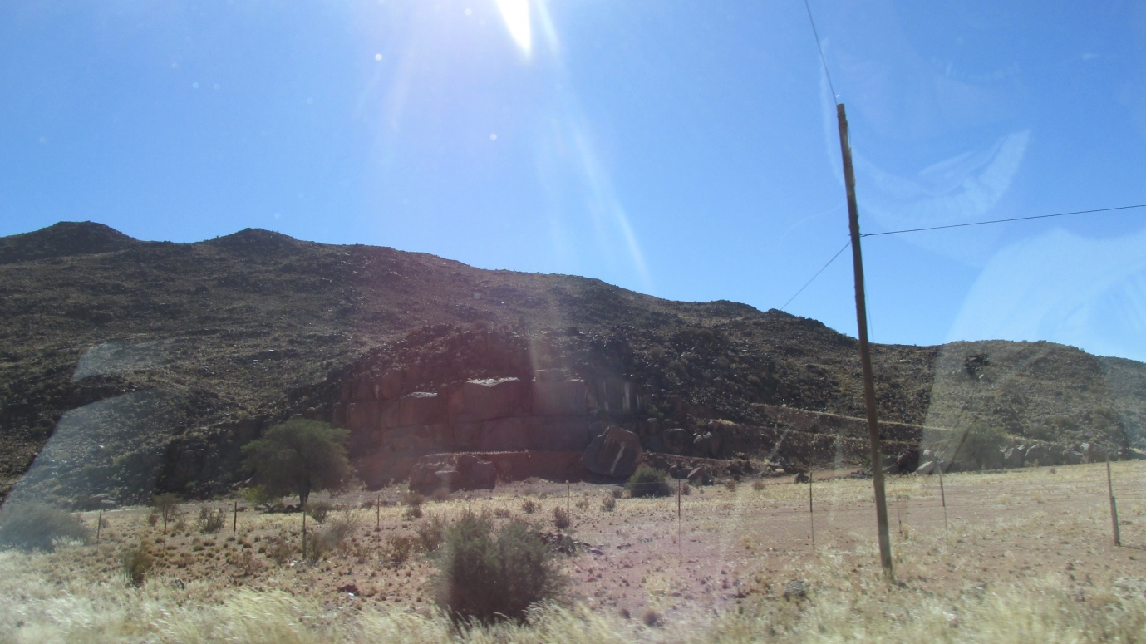
Figure 20: Hill on the right hand side of Onseepkans road heading towards Paulputs substation
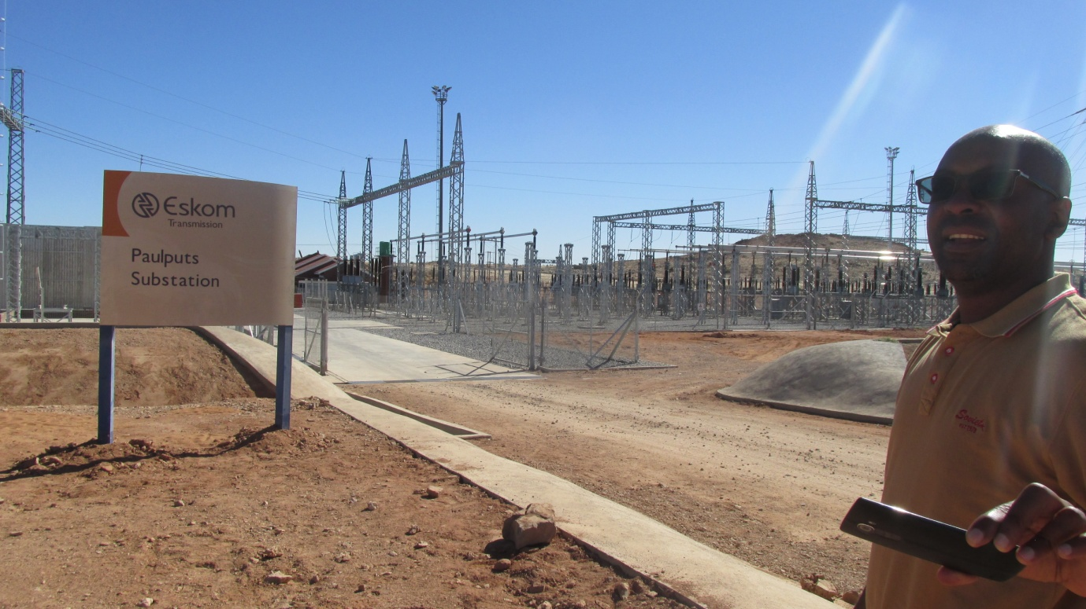
Figure 21: Entrance area at Paulputs substation
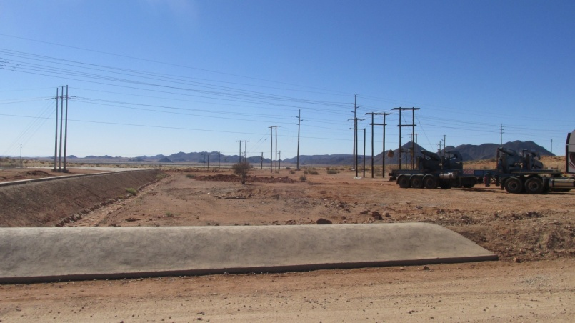

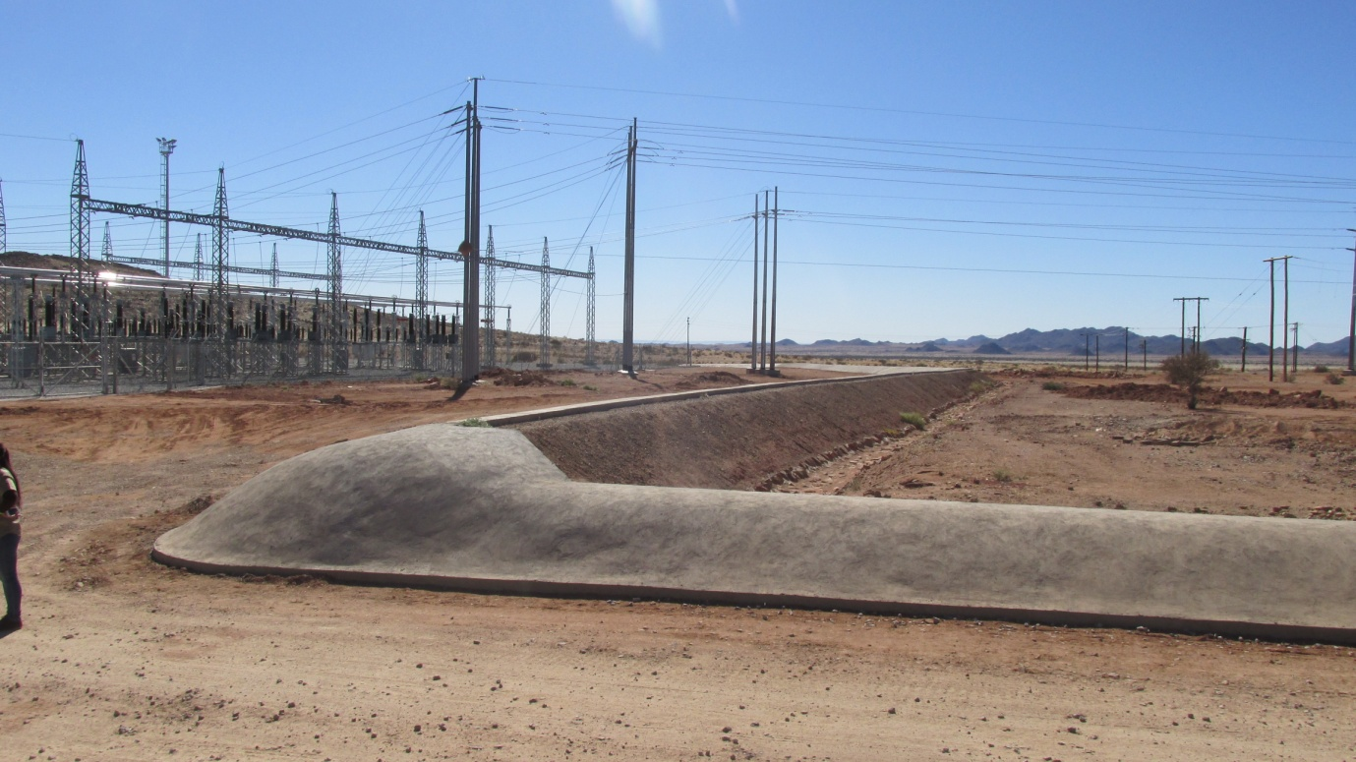
Figure 22: Other surroundings out side Paulputs substation

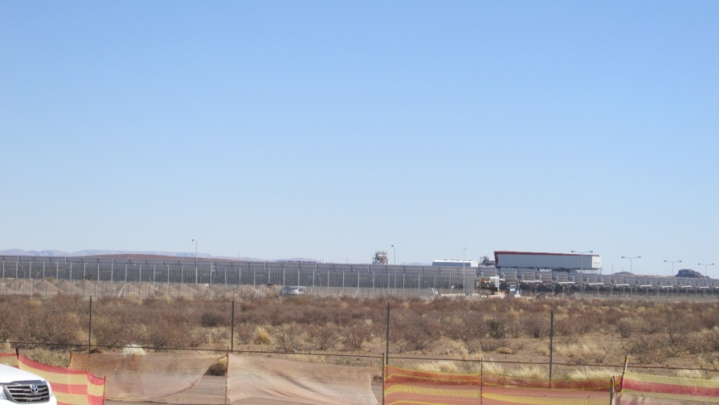
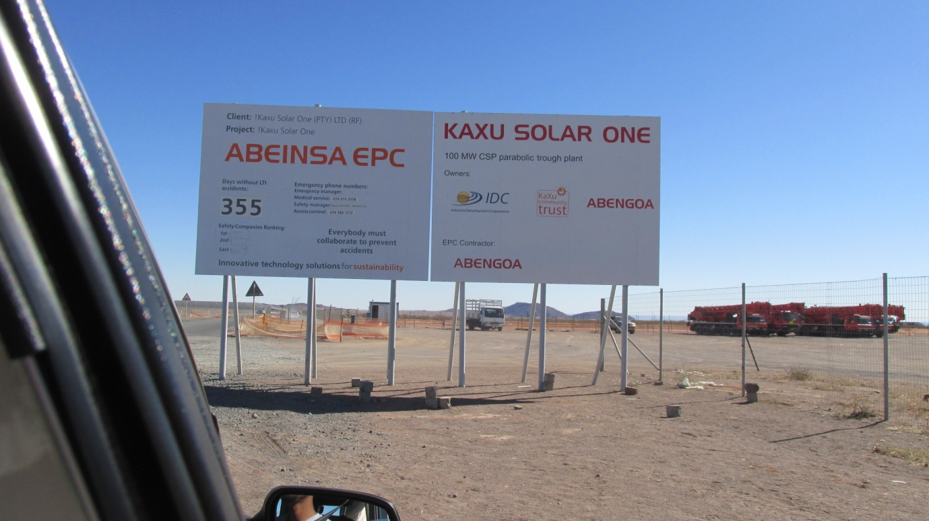

Figure 23: Solar Energy Facility Development near Paulputs substation

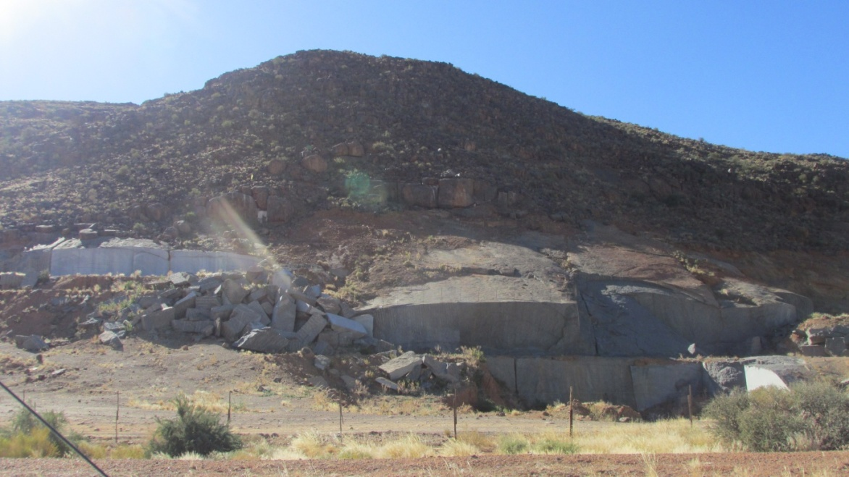
Figure 24: Hill on the left hand side of Onseepkans road heading out of Paulputs and Solar Energy facilities, which marks the end of the Study area.

